


Announcement for the Manfred Lachs Space Law Moot Court Competition for 2026

CAPACITY BUILDING
IN SPACE REGULATION

16th AFRICA REGIONAL ROUND
of the
MANFRED LACHS SPACE LAW MOOT COURT COMPETITION
25 – 27 May 2026
(Monday – Wednesday)
Online session

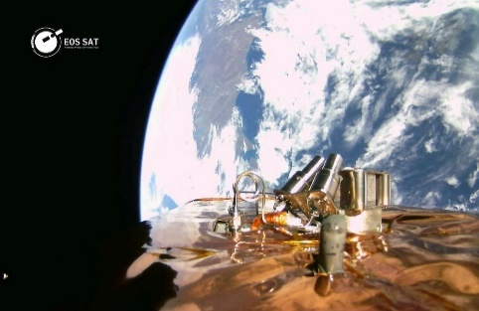
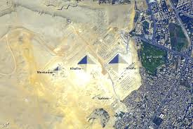

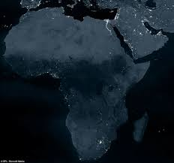

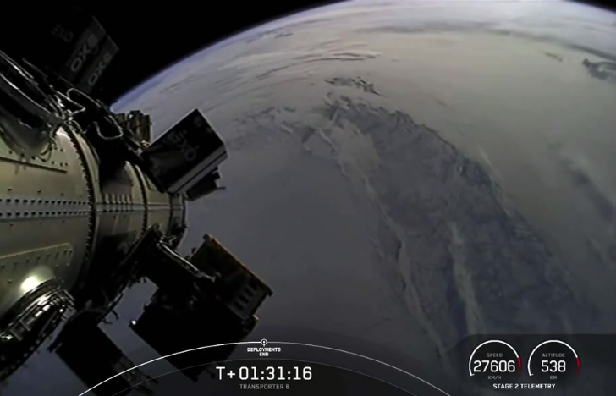

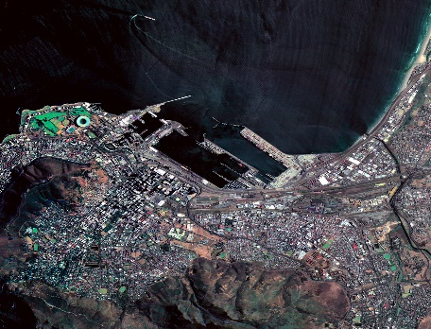


Schedule for 2025
Manfred Lachs Space Law Moot Court Competition
Calendar: Africa Region

Inkaton (Applicant) vs. v. Accadia (Respondent)
Case Concerning “Liability and Responsibility for Space Activities of Non-Governmental Corporate Actors”

A F R I C A R E G I O N

03 November 2025 | Initial invitation letters draft and sent by e-mail to Deans, Lecturers and Previous Students
24 November 2025 | Registration Deadline: Reminders sent!
27 November 2025 | Registration Deadline:  A f r i c a R e g i o n  (Note that there is NO any registration fees)
16 January 2026 | Deadline for Submission of Requests for Clarifications
30 January 2026 | Deadline for the Author of the Problem to give Response to Requests for Clarifications
06 March 2026 | Deadline for Memorials for RSA Universities:  SOUTH A F R I C A NATIONAL ROUNDS
18 – 20 March 2026 | RSA National Rounds
23 – 27 March 2026 | The week reserved for the National Rounds for the Country – Level Competitions
31 March 2026 | Deadline for Memorials:  A f r i c a R e g i o n
25 – 27 May 2026  (Wednesday - Friday) | Regional Oral Rounds, All options or participation to be exhausted
28 – 29 May 2026 | MC GILL CONFERENCE – DR AGABA
02-06 June 2026 | INTERNATIONAL SPACE SUMMIT AFRICA (ISSA)
19 June 2026 | Deadline for Submission of Written Memorials for World Finals by Regional Winners
The 77th International Astronautical Congress (IAC), scheduled for October 5-9, 2026.  in Antalya, Türkiye (Turkey) | Oral Rounds of Semi-Finals (in-person)

The 2024 Winners of the Regional Rounds of the Manfred Lachs Space Law Moot Court Competition 2024 was the Midlands State University(MSU) from Zimbabwe, who represented Africa at the World Finals.
From left to right: National Coordinator Ms Beauler Whozhele, Students: Watson Somerai, Grace Charumbira, Team Coach : Mr.Claudios Makwara, Ms Siphathisiwe Lunga and Adv Lulekwa Makapela of CSIR;(NEOSS) South Africa.
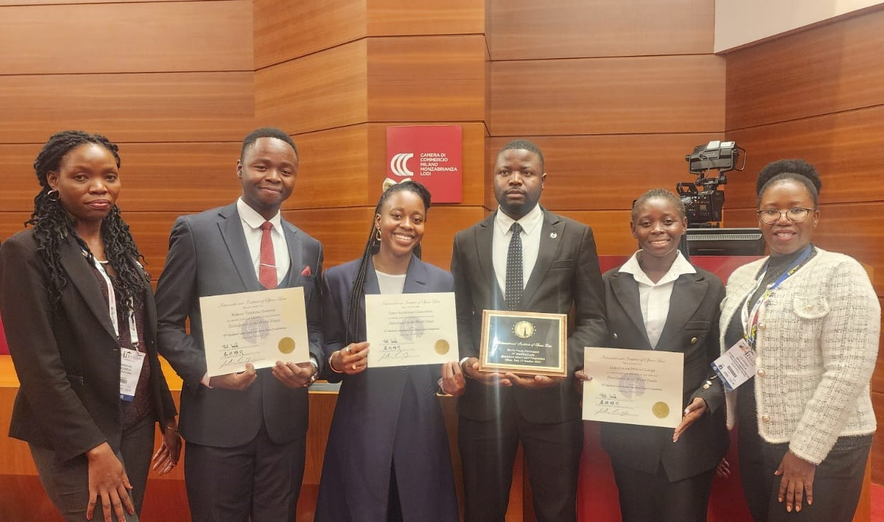
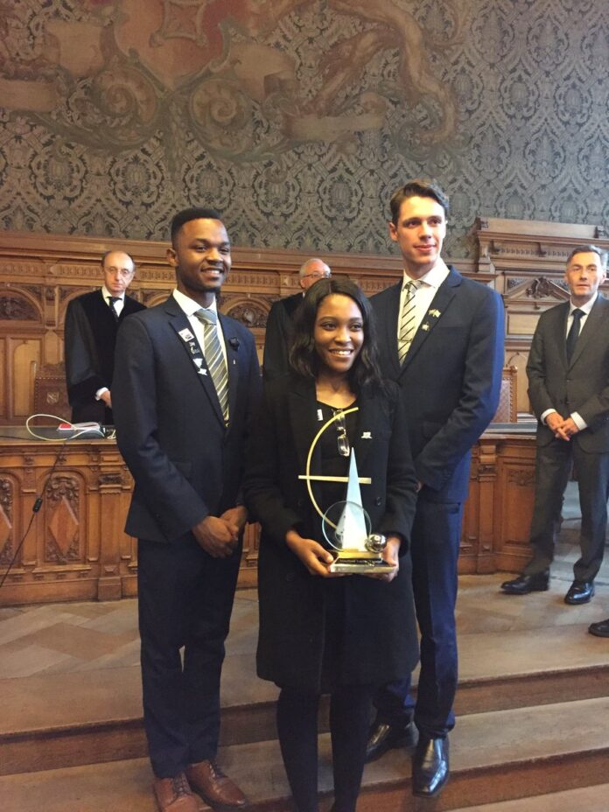  Ruvimbo Samanga (Middle) with the winning Students from the University of Pretoria, South Africa - Winners of Manfred Lachs Space Law Moot Court Competition World final 2018 | 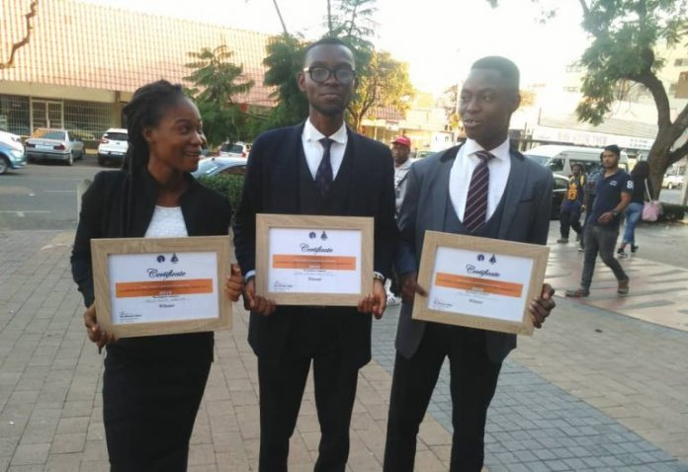  University of Calabar students, who won the Semi-Finals of the 2019 Manfred Lachs Space Law Competition against the McGill University team which represented the North America region.
  On the 3rd of July, 2020, the University of Pretoria was announced as the African Regional Round Winners with Team Members: Simon Motshweni, Nicholas du Toit and Kgomela Letsoalo (L-R) | TIMELINE:  For 2021, the University of Pretoria team, which consisted of Meesrs. Thuwaybah Moses, Rorisang Moyo, and Thubelihle Dumisa as coached by Nicholas Pieter du Toit participated at the 2021 World Finals  In 2022, warm congratulations were sent to the Midlands State University (MSU) of Zimbabwe, which was participating for the first time, for taking the Africa Region Round of the Manfred Lachs Space Law Moot Court Competition
 |   Judges; Adv’s Icho Matlou & Lulu Makapela with Regional Coordinator (Ms Majaja) in the middle and Organisers for 2023 from the dtic; Ms Jolisa & Ms Madubela(L-R)

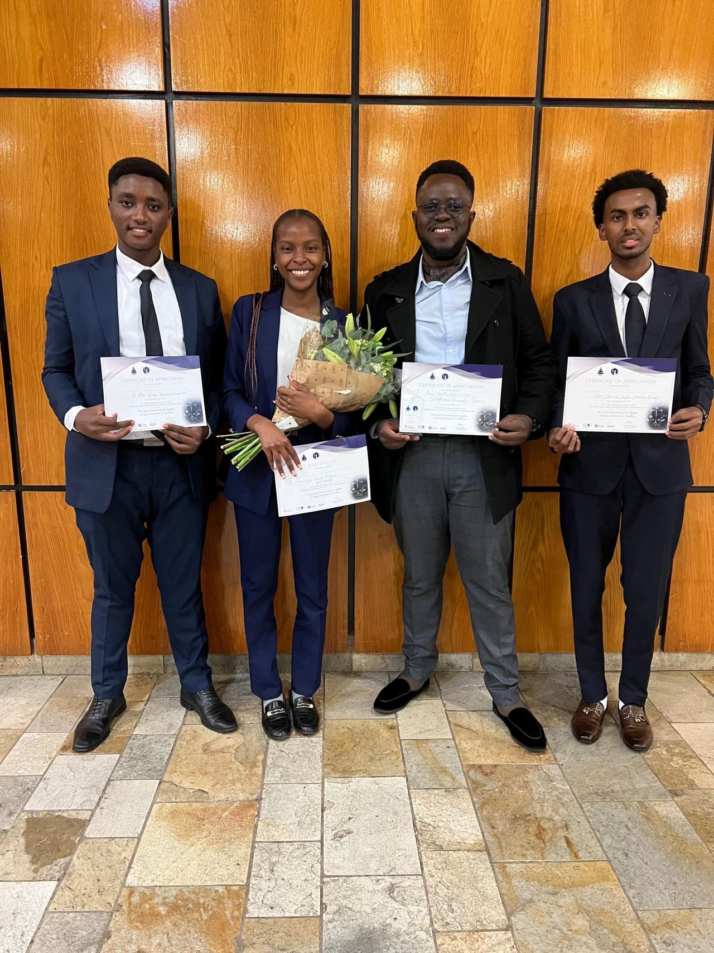

The 2025 winners of the Africa Regional Round of the Manfred Lachs Space Law Moot Court Competition: Strathmore University from Kenya has won the 2025 Africa Regional Round of the Manfred Lachs Space Law Moot Court Competition, becoming the first Kenyan institution to advance to the global finals.

CURRENT 2025 WORLD STANDINGS
World Champion | Semi-finalist(s) | Best Oralist | Best Memorials
2025 (Sydney), Australia | North America: New York University (1) | Europe: University of Luxembourg (1) | * Africa: Strathmore University  * Asia Pacific: Singapore Management University

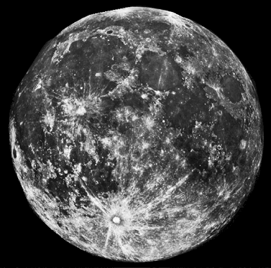

CONTACT PERSON

Ms. Nomfuneko Majaja
Department of Trade, Industry and Competition (the dtic)
Cell: 0798818128
E-mail: nmajaja@thedtic.gov.za
nmajaja@gmail.com
International Institute of Space Law (IISL)
Email: lachsmoot-africa@iislweb.org
IISL Website: http://www.iislweb.org/lachsmoot
South African Council for Space Affairs (SACSA)
SACSA Website: http://www.sacsa.gov.za/schedule-for-2024-manfred-lachs-space-law-moot-court-competition-calendar-africa-region/

